JSP Scriptlet tag (Scripting elements)->

In JSP, java code can be written inside the jsp page using the scriptlet tag. Let's see what are the scripting elements first.

## **JSP Scripting elements->**

The scripting elements provides the ability to insert java code inside the jsp. There are three types of scripting elements:

* scriptlet tag
* expression tag
* declaration tag

### **JSP scriptlet tag->**

1. <%  java source code %>

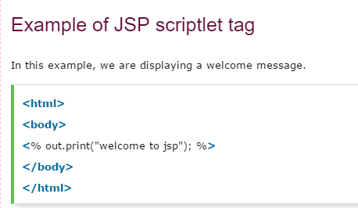

### **Example of JSP scriptlet tag that prints the user name->**

In this example, we have created two files index.html and welcome.jsp. The index.html file gets the username from the user and the welcome.jsp file prints the username with the welcome message.